Measurements
Table of contents
- Load transient response testing using mosfet switch
- Load transient response testing using closed loop load transient tester
- Short circuit recovery
- Capacitive load
- Inductive load
- Output voltage programming (internal)
- Output voltage programming (external)
- Output enable programming
- Change the mode of operation (CV/CC)
- Power on, stand-by and forced power off
- Power on with shorted output

Load transient response testing using mosfet switch
The simplest way to measure load transient response is to use an mosfet as a fast switch that will connect in parallel additional load and in that way increase output current. The mosfet switch (Fig. 1) is driven with signal generator (blue trace on Fig. 2). Output voltage is set to 12 V. Load permanently connected is 8.2 Ω and mosfet switch is repetitively connecting additional 33 Ω. The output current alternates in that way between 1.46 A and 1.83 A. Output voltage is representing by cyan trace and voltage on mosfet input with magenta. Higher difference between two currents will generate higher output voltage disturbance and in this case it is -42 mV (or 0.35 % of output voltage) when additional load is applied (rising edge) and -46 mV (0.38 %) when that load is disconnected (falling edge). Recovery time is delimited with two vertical cursor lines and it is about 250 μs.

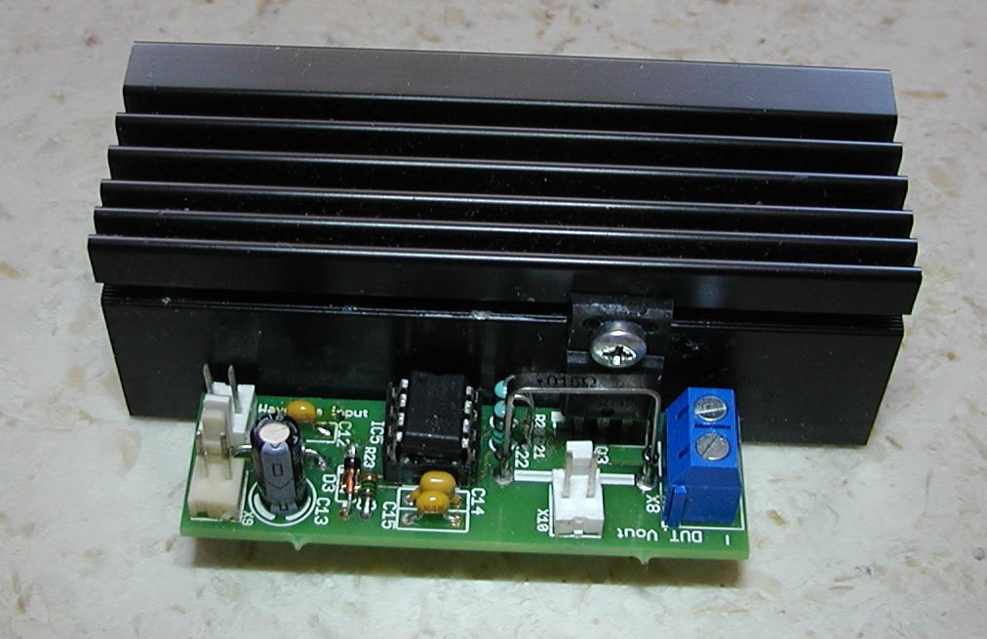Fig. 1: Driver for mosfet switch

Load transient response testing using closed loop load transient tester
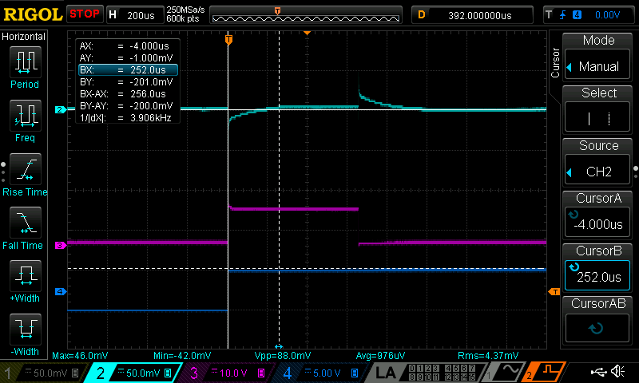Fig. 2: Load transient response tested with mosfet as a switch
The load transient response could be tested also using circuit that is presented in LTC’s AN104. Theory of operation is described in detail in that application note. Schematic shown on page 15 (Fig. D1) are put into diecast aluminum alloy enclosure (Hammond 1590U) together with two transformer for bias supply of +/-15 V (Fig. 3). Eagle files, Gerber and BOM for this tester is available on the GitHub.

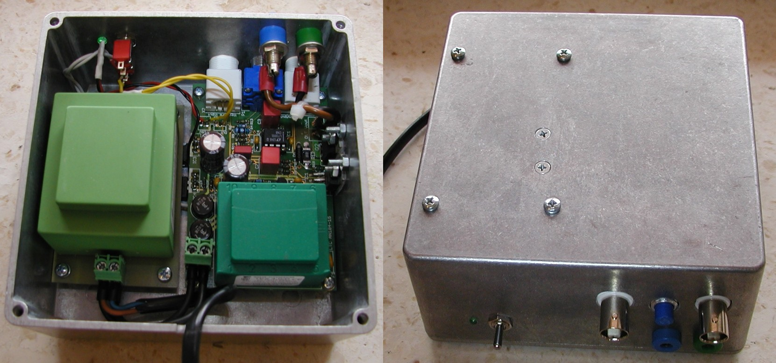Fig. 3: Closed loop load transient tester

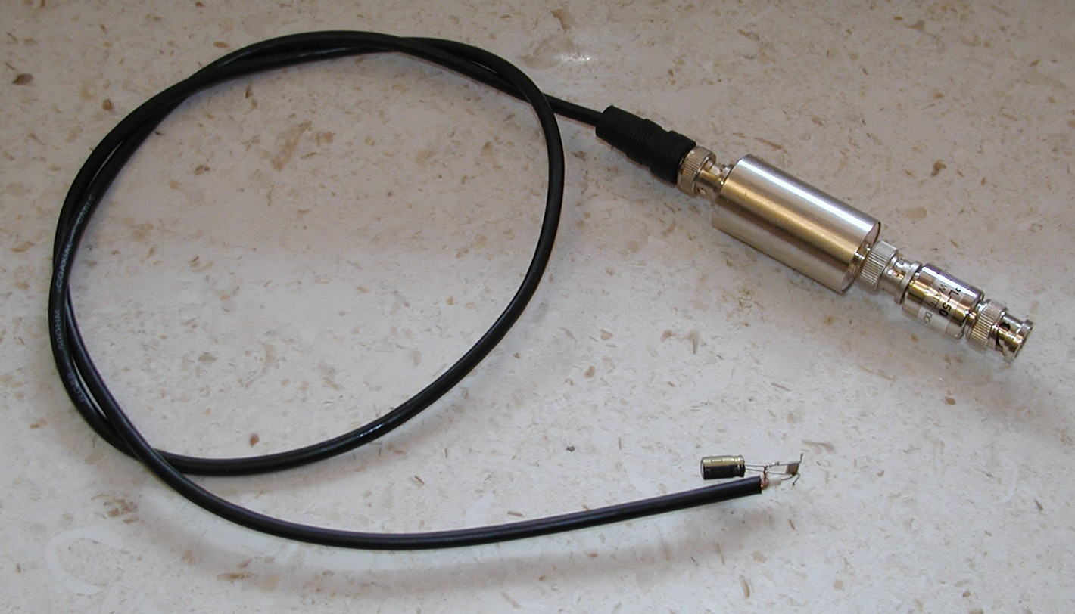Fig. 4: x1 AC probe used for measurements
Voltage measurement is AC coupled and its accomplished with the home-made probe following recommendation that is gave in the same application note on page 14 (Fig. C1). 4.7 μF instead of 10 μF is used and at the tip of the cable additional 10 μF elco in parallel with 470 nF ceramic capacitor is added.

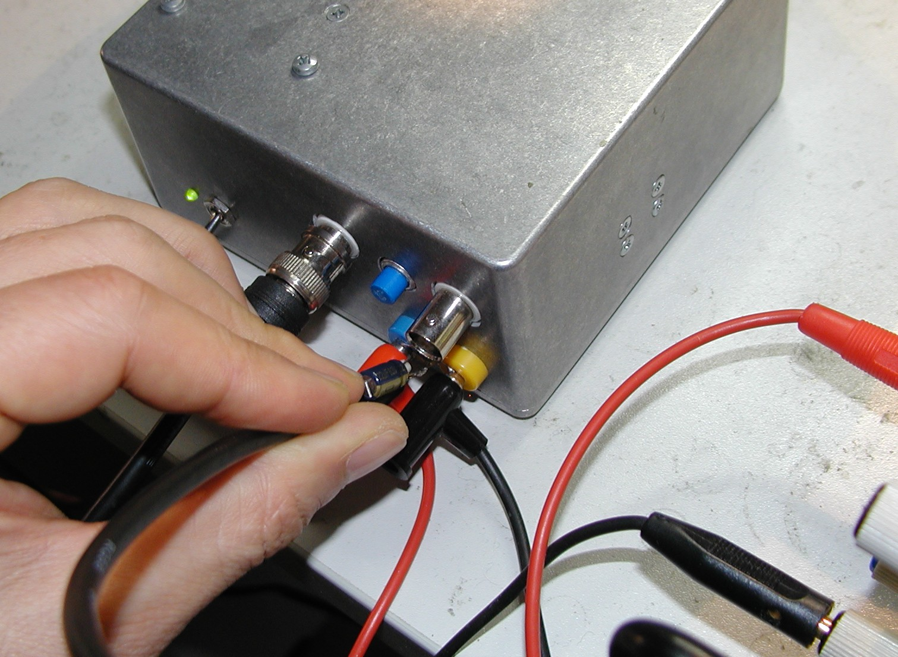Fig. 5: AC probe connection on tester's input terminals
Measurements are conducted on the input terminals of the tester as shown on Fig. 5. The power supply output is set to 20 V with current set to maximum value to avoid entering CC mode of operation.
Result shown on Fig. 6, 7 and 8 is generated with 1 V_{pp} signal (4 kHz, 20 % duty cycle) what is corresponding to 1 A change on top of continuous load (DC bias) set to 1 A.

Important: this tester should be used with special precaution if programmed output voltage of the power supply is higher then 25 V otherwise that will result with instant damage of used switching transistor (D44H11). Reason for that is limited SOA because it can accept e.g. only 600 mA when V_{ce} is 30 V.

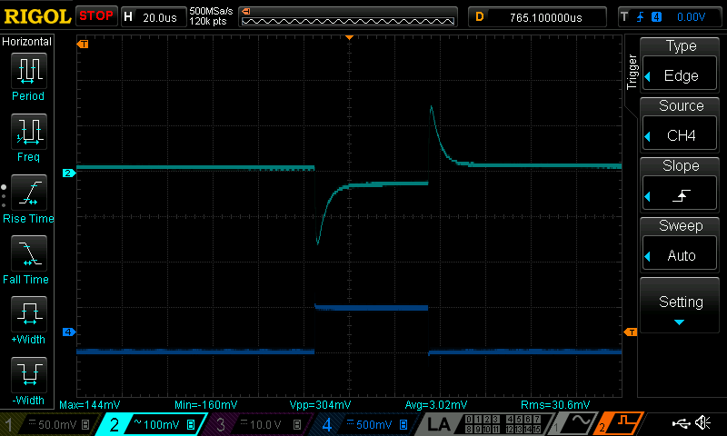Fig. 6: Transient response with closed-loop tester
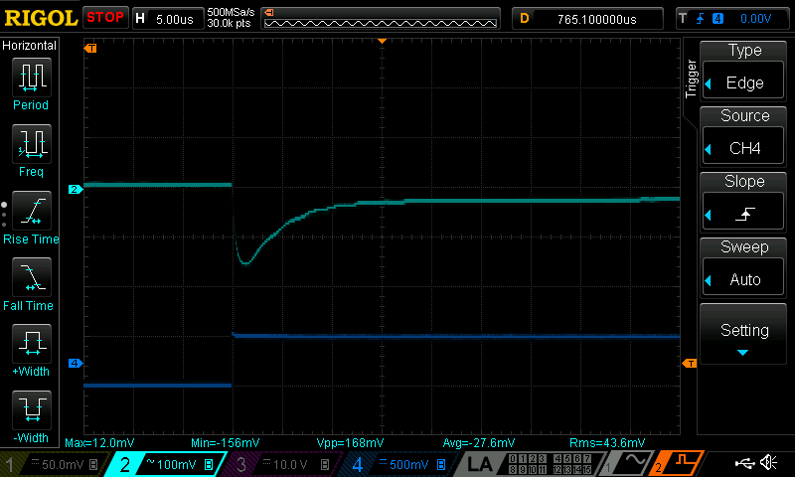Fig. 7: Transient response with closed-loop tester (rising edge)

Short circuit recovery
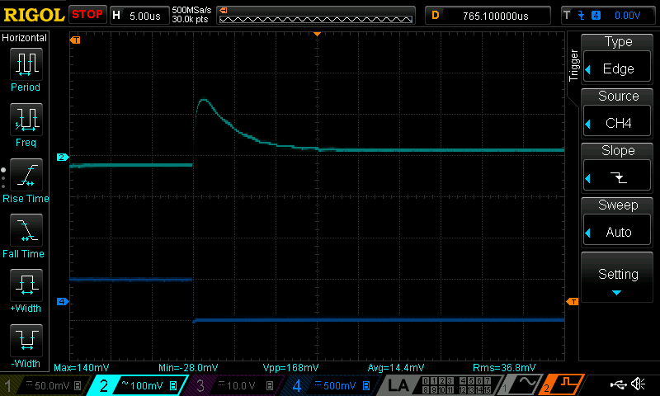Fig. 8: Transient response with closed-loop tester (falling edge)
Testing short circuit is accomplished using the mosfet switch (Fig. 1) directly connected to the power supply’s output terminals. Output voltage is set to maximum for tested model that is 40 V. Output current is also set to maximum value of 5 A. On Fig. 9 cyan trace represents output voltage, magenta mosfet gate signal that is derived from input signal that comes from signal generator (blue trace). Recovery from shorted output last about 1.7 ms.

Capacitive load
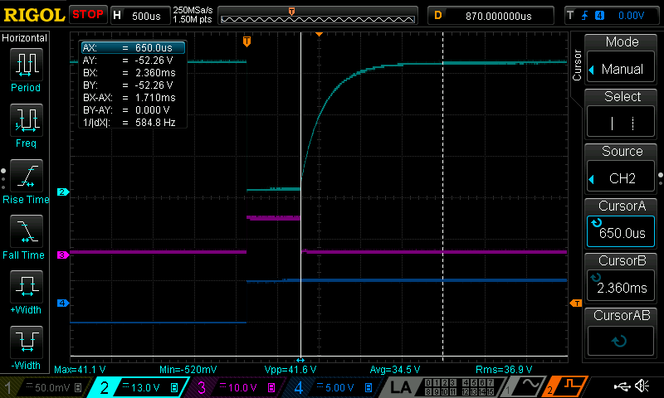Fig. 9: Short circuit recovery
The capacitive load testing is performed with simply connecting capacitor to the output terminals with oscilloscope probe already connected when huge drop in output voltage is expected with not previously charged capacitor. Fig. 10 shows what’s happened when output voltage is set to 40 V and 10 000 μF elco is connected.
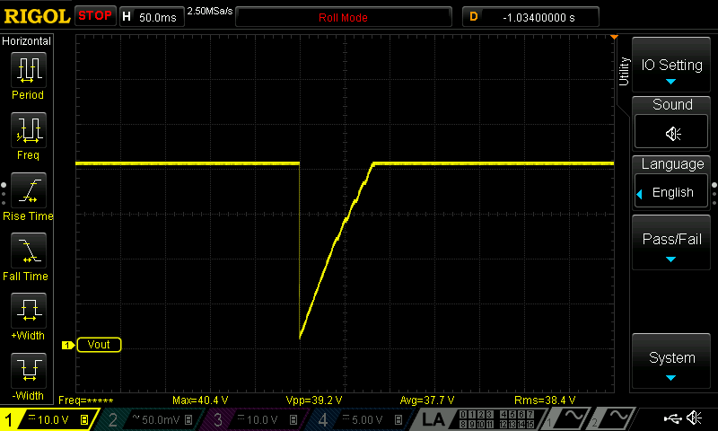Fig. 10: Output voltage drop when huge capacitor is connected
Another scenario was to leave capacitor connected and program output using the OE signal. The DP (down-programmer) circuit was left active that capacitor can be discharged before the output is enabled again.

Inductive load
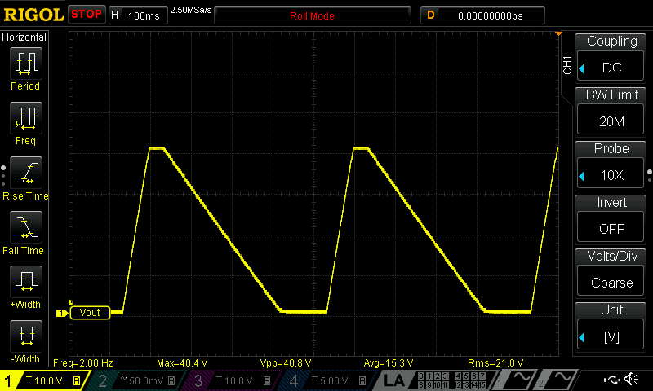Fig. 11: Output controlled with OE signal and 2200 μF capacitive load
We tested two types of inductive load, a RS540 type DC motor and 100 μH power inductor (Bourns 2312V series). DC motor is connected directly and bypassed with additional 100 μF elco capacitor. It generates many spikes but no oscillation is visible.

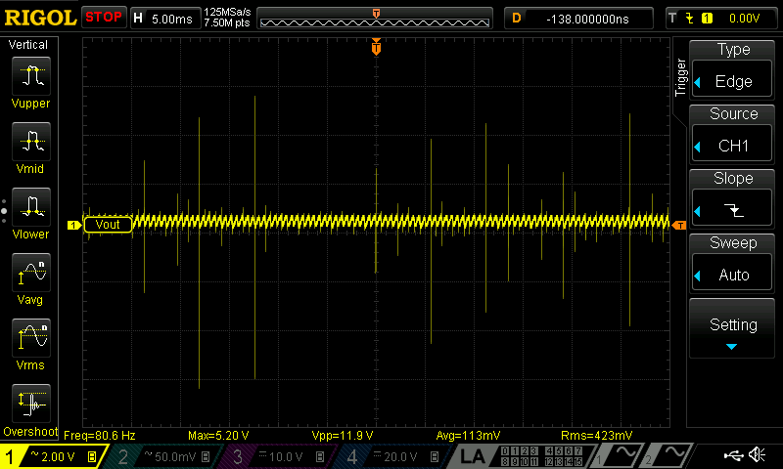Fig. 12: Output voltage with DC motor connected (timebase 5 ms)
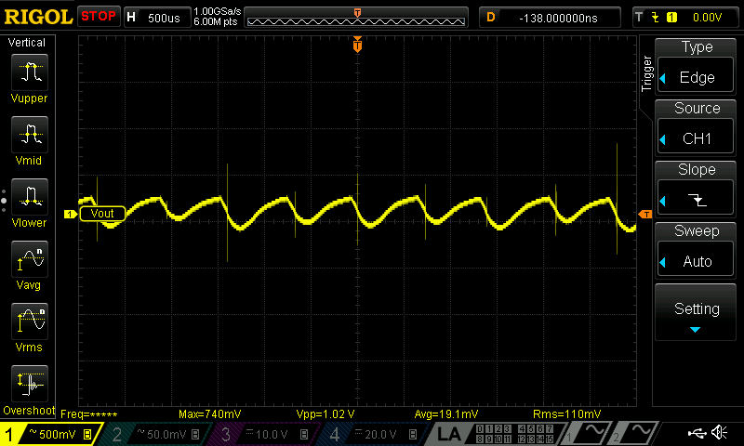Fig. 13: Output voltage with DC motor connected (timebase 0.5 ms)
Power inductor is not continuously connected to the output but mosfet switcher (Fig. 1) driven with 100 Hz signal is used (yellow trace represents output voltage, magenta is mosfet gate signal, and blue is signal generator output).

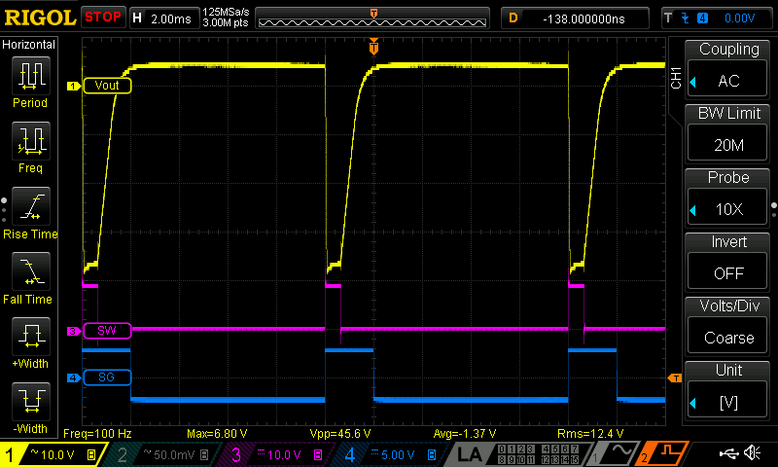Fig. 14: Inductive load testing (Vout=40 V, Iout=1 A)

Output voltage programming (internal / DAC)
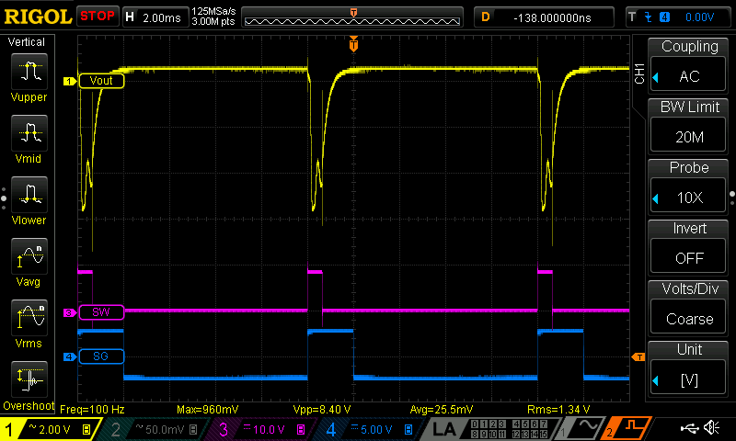Fig. 15: Inductive load testing (Vout=5 V, Iout=2.5 A)
Testing the output voltage programming can show if undesirable overshoots and undershoots exists while output voltage is changed from lower to higher value and vice versa. This test also shows rising (up-programming) and falling (down-programming) time. Result shown on Fig. 16 is generated with changing output voltage on 40 V model from 2.5 V (DAC code 0x1000) to 10 V (DAC code 0x4000) and back to 2.5 V without load connected.

Output voltage programming (external)
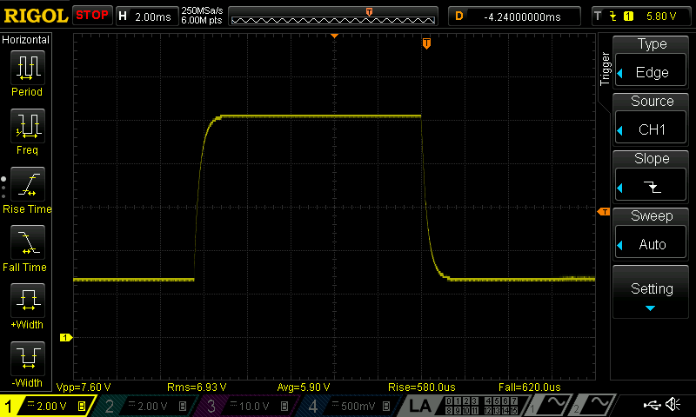Fig. 16: Output voltage programming (internal)
Power channel’s voltage output can be also programmed from external source using protected input that is accessible via front panel connector located on the Arduino shield. As in case of internal programming +2.5 V is required for full scale. In this mode of operation is possible to measure maximum settling time because input analog control signal is applied directly to the CV control loop.
If programming input is 1.25 V it will set output voltage to +20 V for the tested model and difference between rising edges represents settling time that is 120 μs as shown in Fig.17 without load connected. Fig. 18 shows output with load connected. External programming can also show benefit of down programmer circuit. Without load the PSU requires 460 μs to reach zero from half scale.

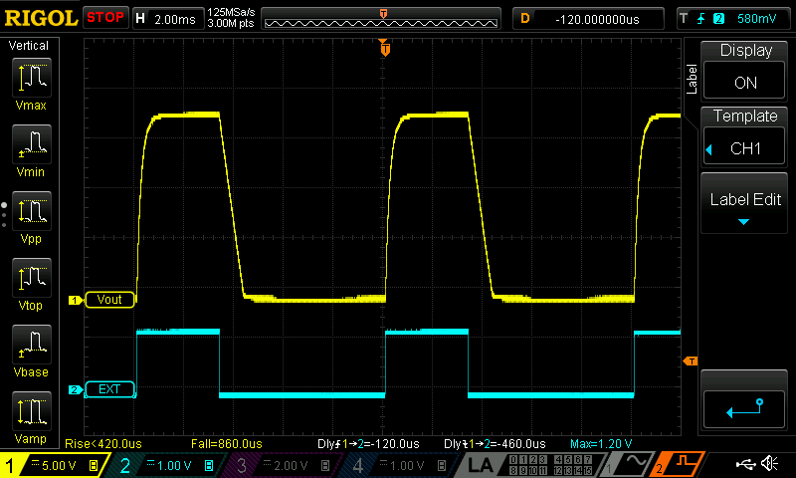Fig. 17: Output voltage programming from external source (1.25 V, 100 Hz), no load connected

Change the mode of operation (CV/CC)
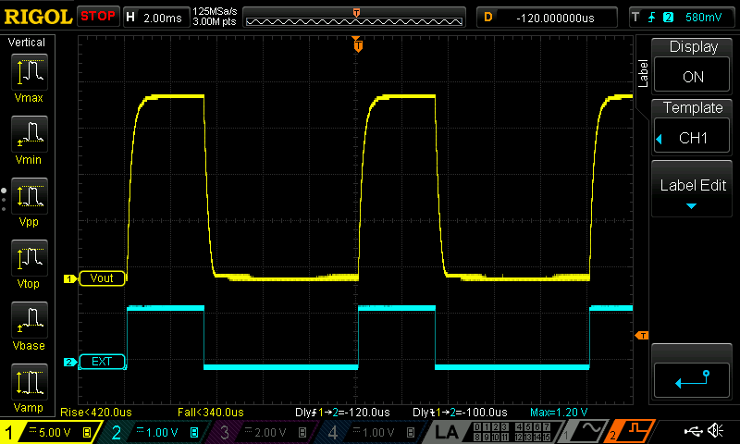Fig. 18: Output voltage programming from external source (1.25 V, 100 Hz), load 16.4 Ω
The PSU will change the mode of operation when some of the programmed output value is reached. For example if output current is set to 100 mA the output voltage that is set to 20 V will remain unchanged as long as connected load does not sink more then set current, therefore its resistance has to equal or greater then 200 Ω. Any sudden change in resistance that could change a mode of operation has to be smooth – no oscillation nor overshooting are permitted during transition mode. This test is performed by repetitively connecting and disconnecting 33 Ω load with mosfet switch (Fig. 1) driven by 10 Hz from the signal generator. Output voltage is set to 40 V and current to 250 mA therefore when load is applied the PSU should change mode from CV to CC what will cause output voltage drop to ~8 V.

Output enable programming
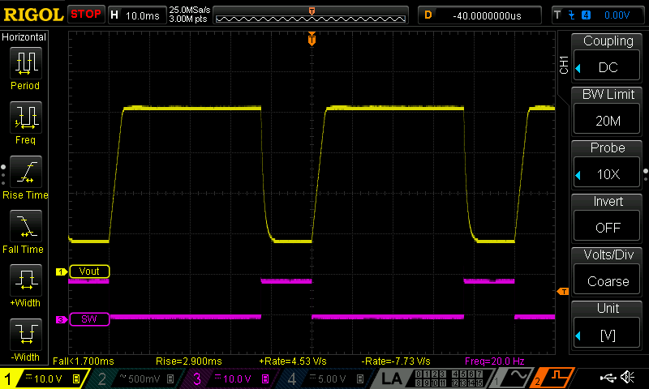Fig. 19: Changing the mode of operation
Output enable programming should have the same effect as output voltage programming from value greater then zero to zero volts using the DAC. But since output enable is a different circuit it has to be tested separately to find out if overshooting and undershooting exists. Two cases are tested without load connected: changing output state with voltage set to 2.5 V (Fig. 20) and with voltage set to maximum that is 40 V for the tested model (Fig. 21). Difference in falling time (down-programming) is clearly visible (<260 μs versus 1.78 ms).

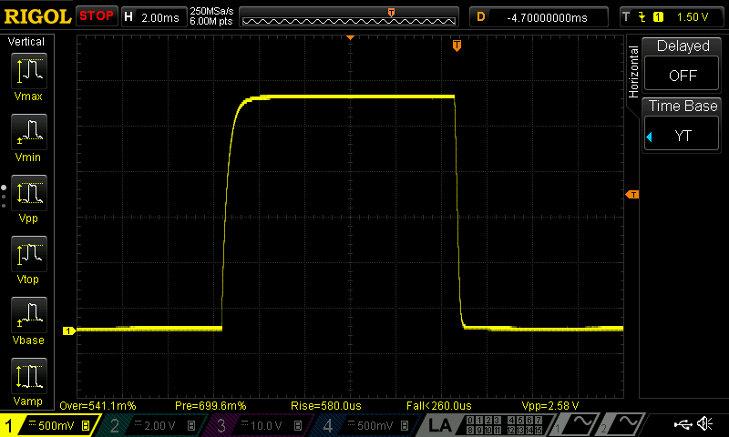Fig. 20: Output enable testing (Vout=2.5 V)

Power on, stand-by and forced power off
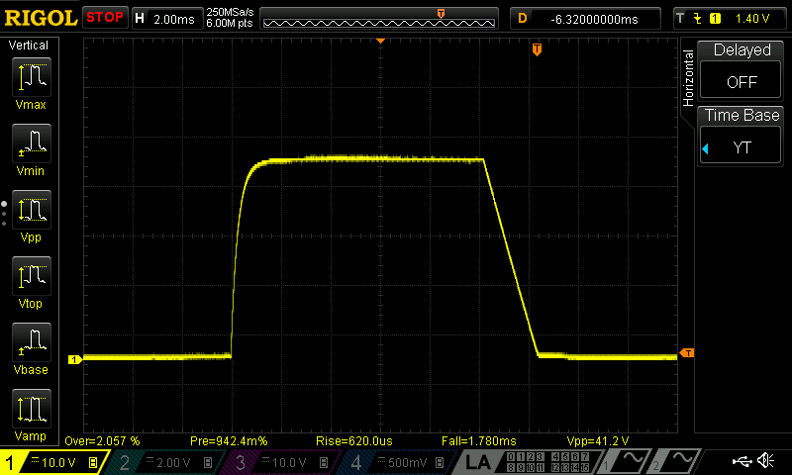Fig. 21: Output enable testing (Vout=40 V)
When the power supply is powered on programmed output voltages also should not show signs of overshoot. In principle this is the same scenario as above mentioned output enable programming that follows output voltage programming. The moment when the power supply’s channel output reach programmed value after it’s powered on is shown on Fig. 22. Well defined transition from no voltage to the set voltage is not a surprise since powering is under control of MCU and it is accomplished long enough after all pre-regulator and post-regulator circuits are stabilized.

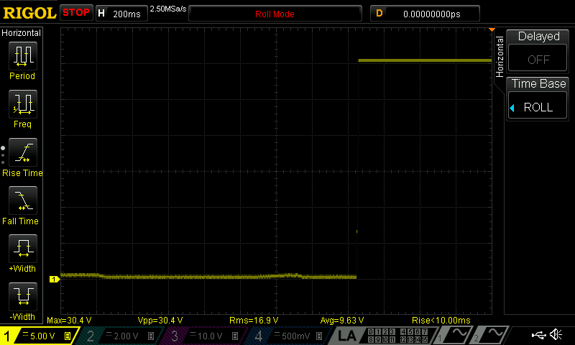Fig. 22: Power on with output voltage set to 30 V
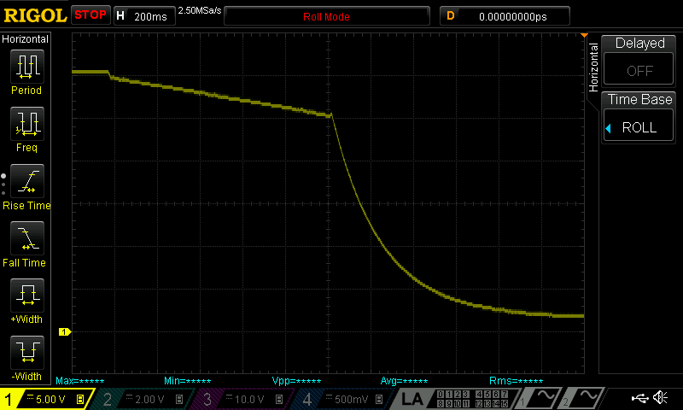Fig. 23: Power off (AC mains unplugged, Vout=30 V, no load)
Fig. 23 and 24 shows what is happening when AC mains is forcibly unplugged without and with load connected (100 Ω in this case). Therefore no MCU assistance is possible but no surprises are detected. That is also true with low output programmed (i.e. below operational amplifiers bias voltage of 5 V) – Fig. 25 shows the state of the output with 3 V and no load connected.
Fig. 26 shows output when power off is MCU assisted what represents entering the stand-by mode.

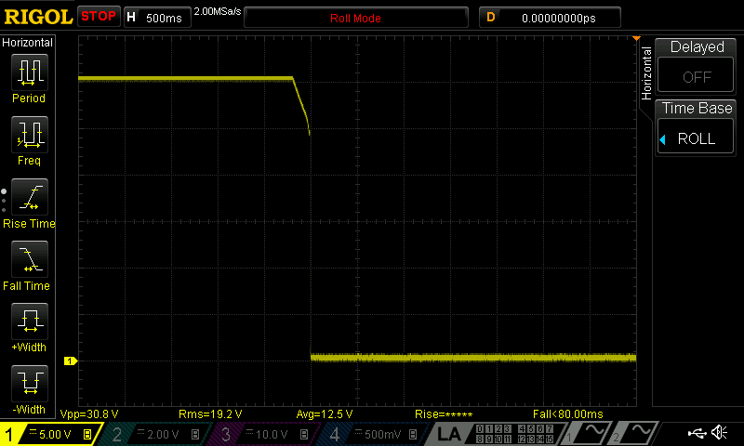Fig. 24: Power off (AC main unplugged) with 100 Ω load connected
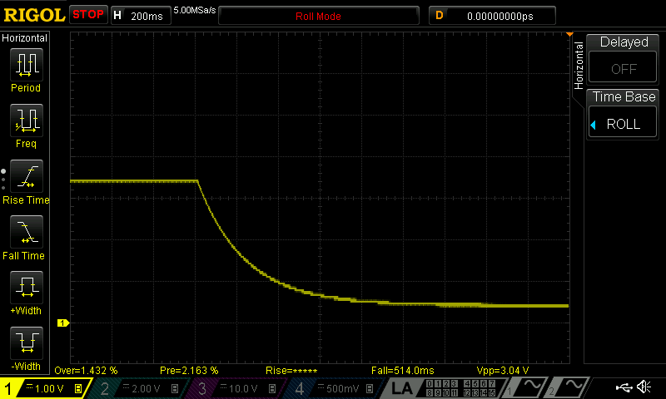Fig. 25: Power off (AC mains unplugged, Vout=3 V, no load)

Power on with shorted output
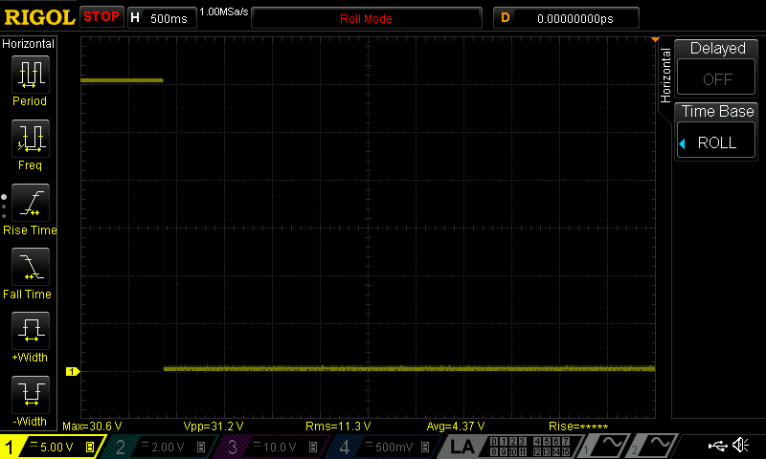Fig. 26: Entering the stand-by mode (MCU controlled)
Finally we wants to know what could happen on the power up while both voltage and current are programmed to the maximum level (40 V, 5 A) when output terminals are shorted. Fig. 27 shows that power supply enters safely such mode of operation and only small peak lasting less then 10 μs can be recorded on the output.

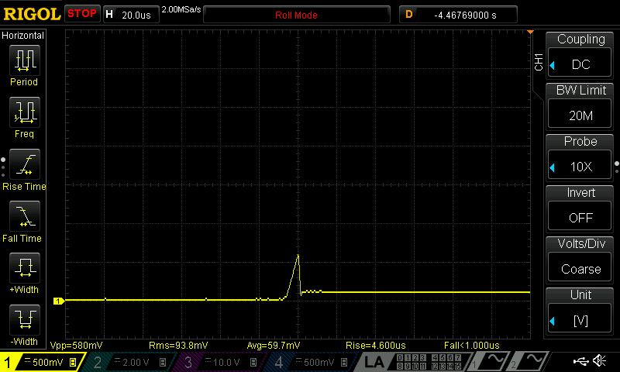Fig. 27: Power on with shorted output

